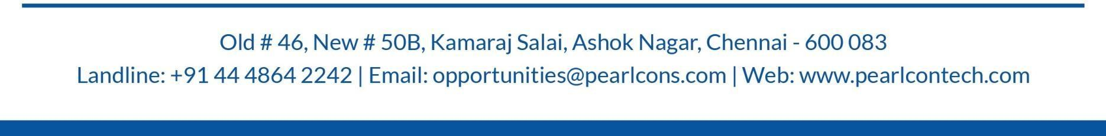


Relieving Letter
Date: 15-11-2025
Dear Mrs. A Swarnalakshmi,
This is Certify that Mrs. A Swarnalakshmi was employed on our rolls and has been relieved from her duties by the close of working hours on 15th of November 2025

Name of the Employee : Mrs. A Swarnalakshmi
Employee ID : PT - 152
Designation : Business Development Executive
Period of Employment : 10st Dec 2024 to 15th Nov 2025

Warm Regards,
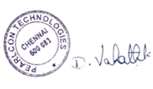
MD & CEO

